**Lab 1 – Instruction execution.**

Your task is to create a program in any programming language with the following functionality:

1. Create your own opcodes.
2. Create your instructions according to the instruction format and corresponding to your program.
3. Instructions may be added dynamically (for any number of instructions).
4. Address CPU registers (PC, AC, IR, I/OAR, I/OBR).
5. Provide a visual representation of program execution (memory address, content in the memory, registers and their content).

Example from the book for reference:

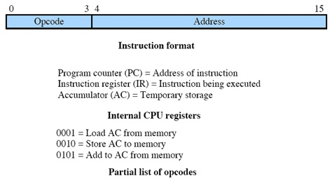

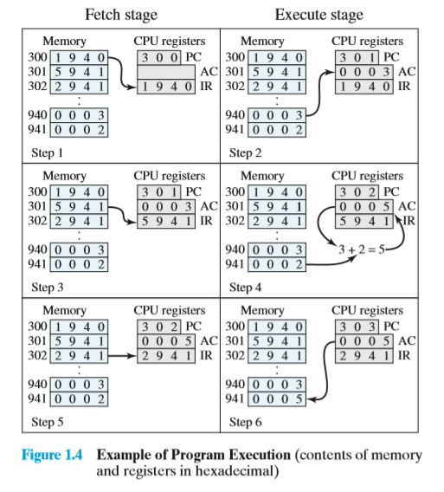

**HARD DEADLINE. -15% for late submission (per week)**